Tf-idf (Term Frequency - Inverse Document Frequency)

* Term frequency measures how frequently a word occurs in the document
* Inverse document frequency decreases the weight of words commonly used in the document and increases the weight of words not used very often in the document
* Tf-idf is the multiplication of these two quantities for each word (frequency of each word adjusted for how often it occurs)
* Document in this case is a magazine
* The charts below are the 10 items (single words, bigrams, trigrams) with the highest tf-idf

**Single Word tf-idf**

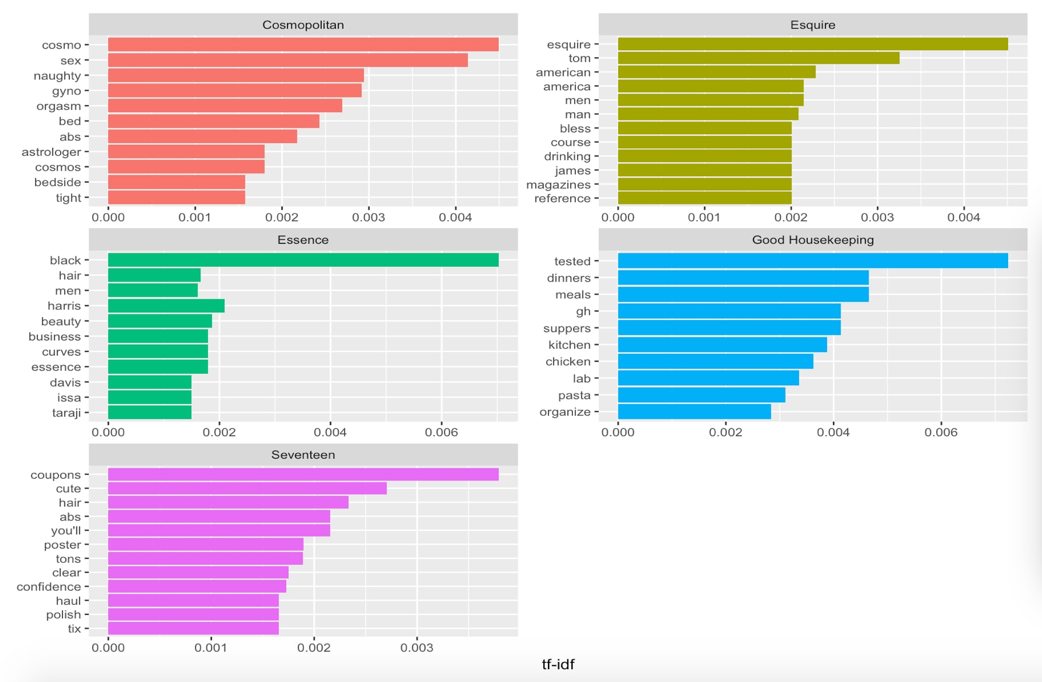

**Bigram tf-idf**

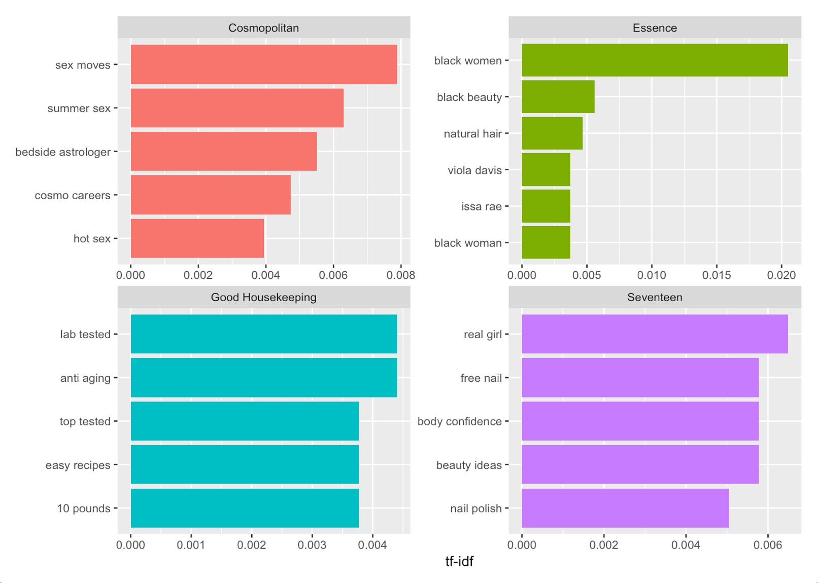

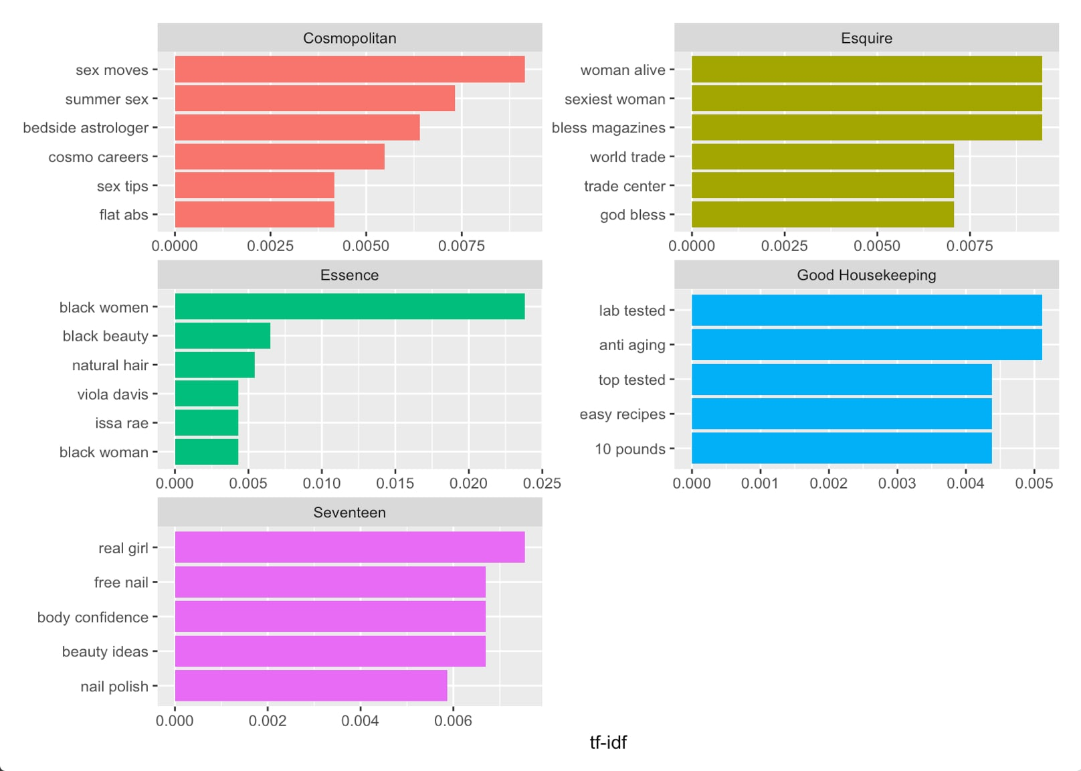

**Trigram tf-idf**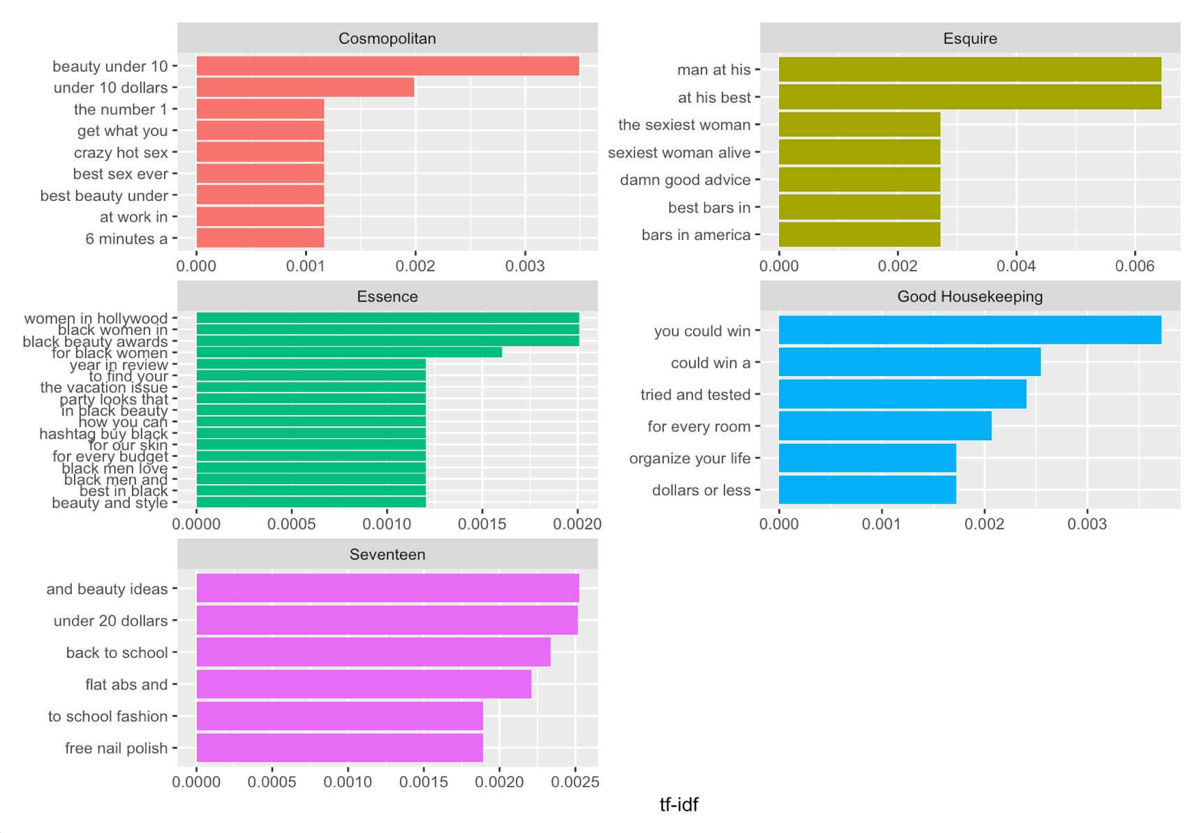

**Other preliminary visualizations**

Pairwise correlation

* Measure of how frequently words appear together on a magazine cover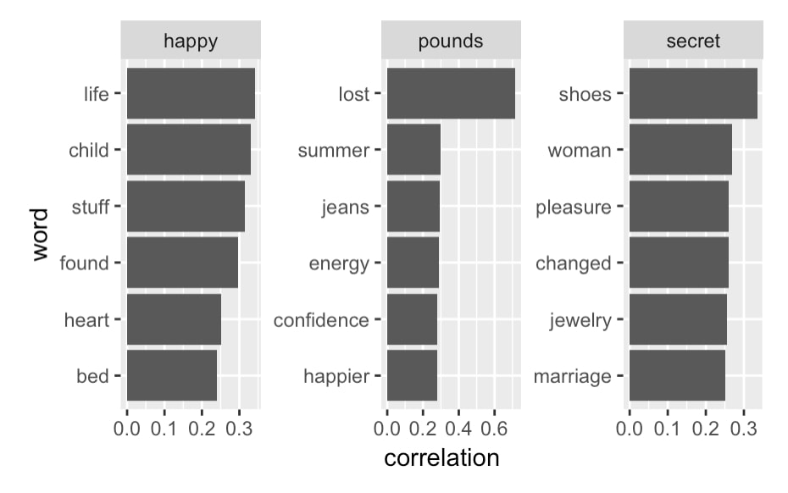

**Word Clouds!**

Simple cloud (word frequencies) Comparison cloud (comparing word frequencies across magazines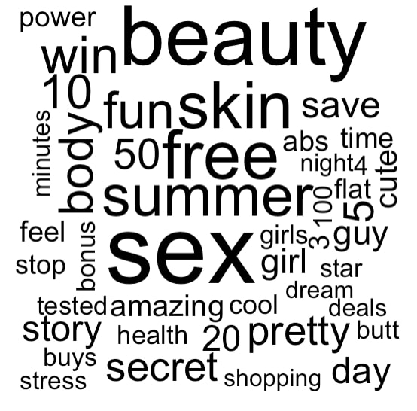

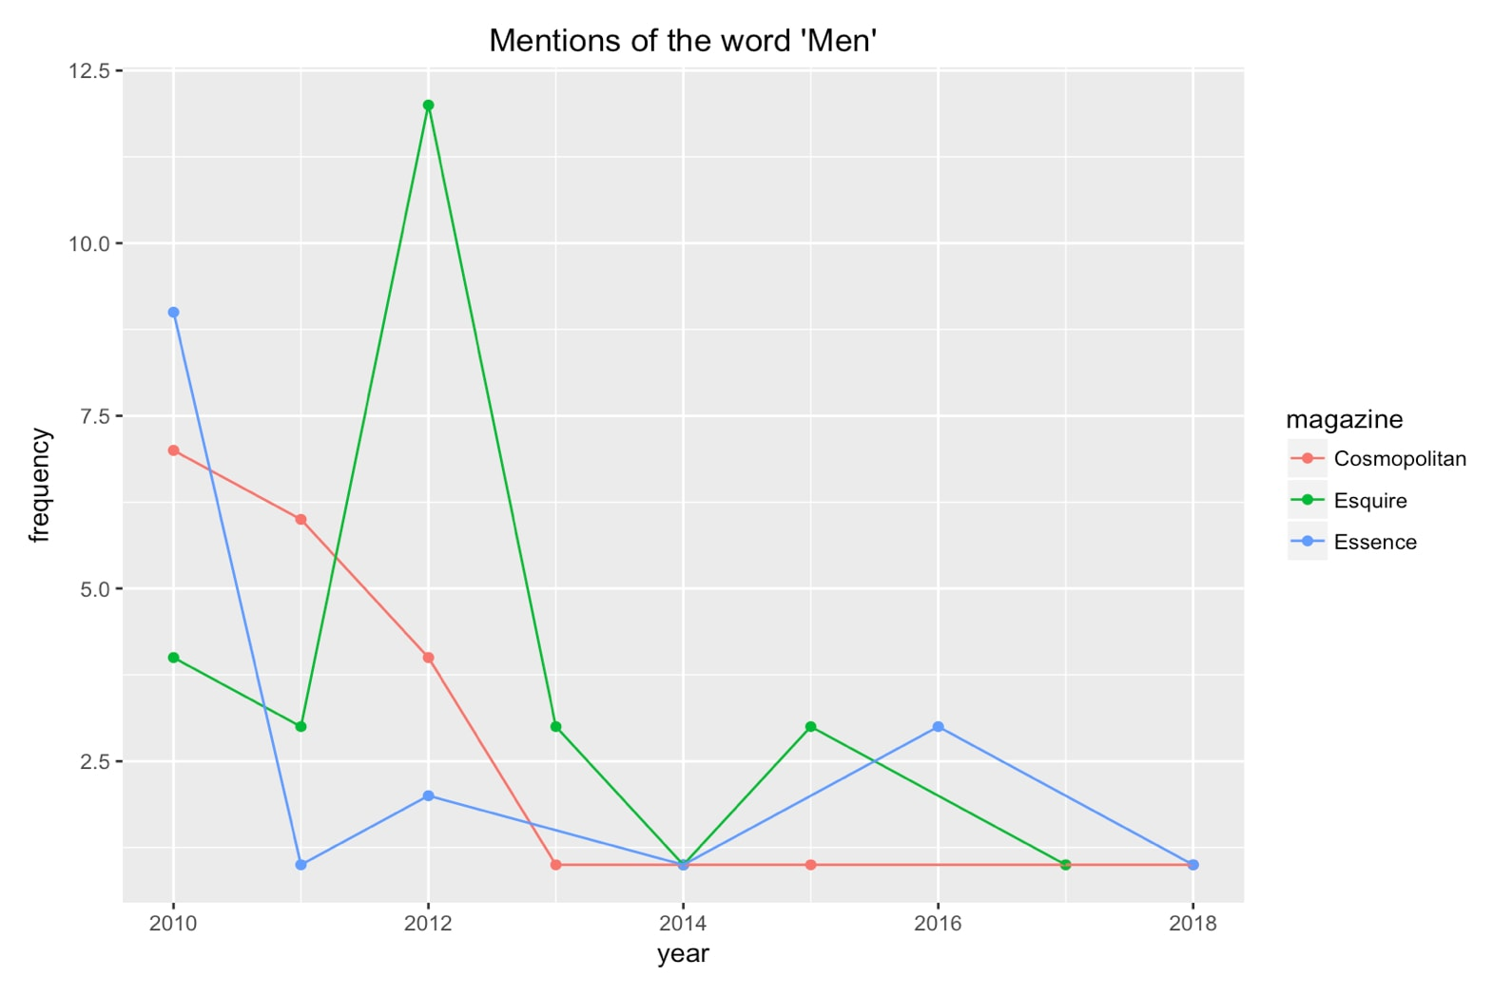

**Commonality cloud (words that appear in all magazines, size proportional to frequency)**

All magazines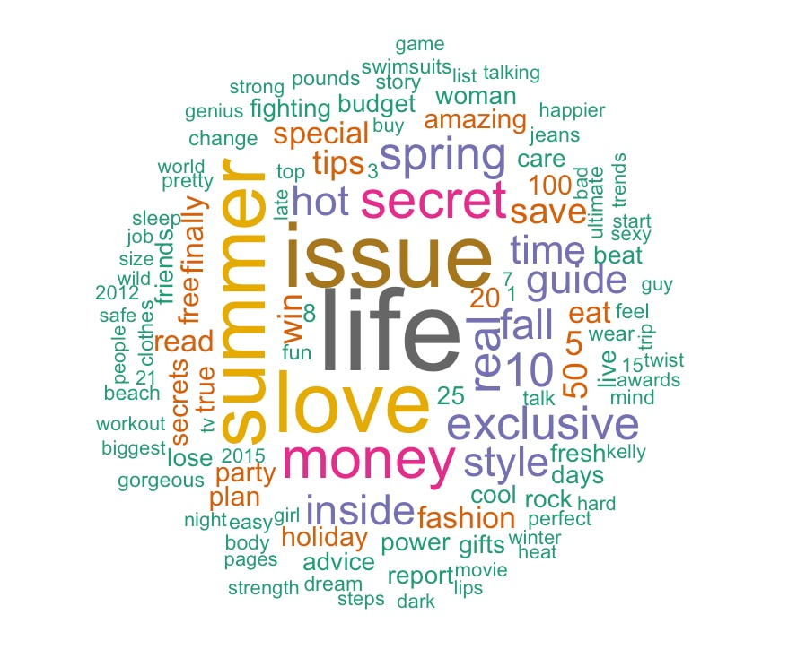

Women’s Magazines



**Some example graphs of word frequency over time**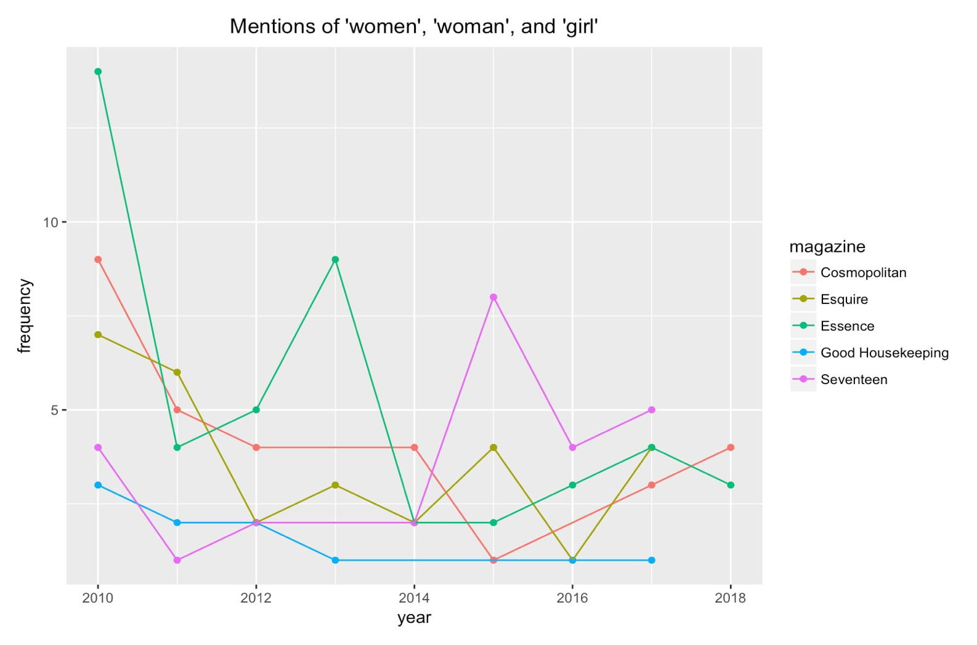

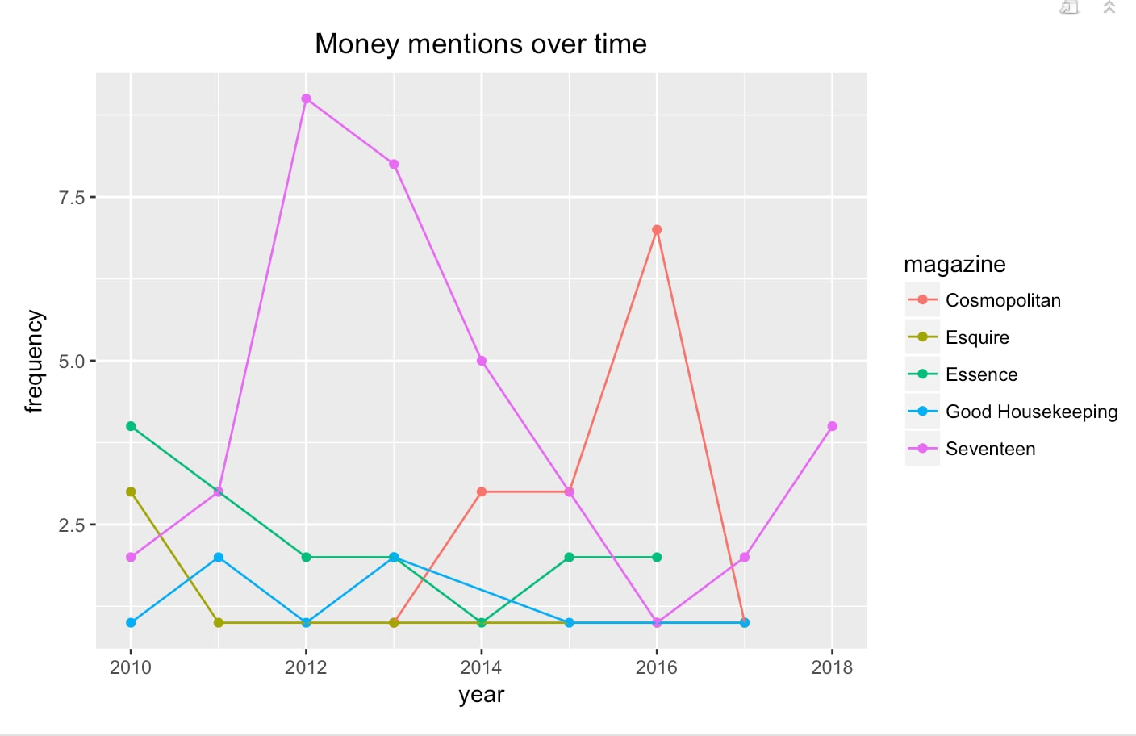

**Sentiments Analysis**

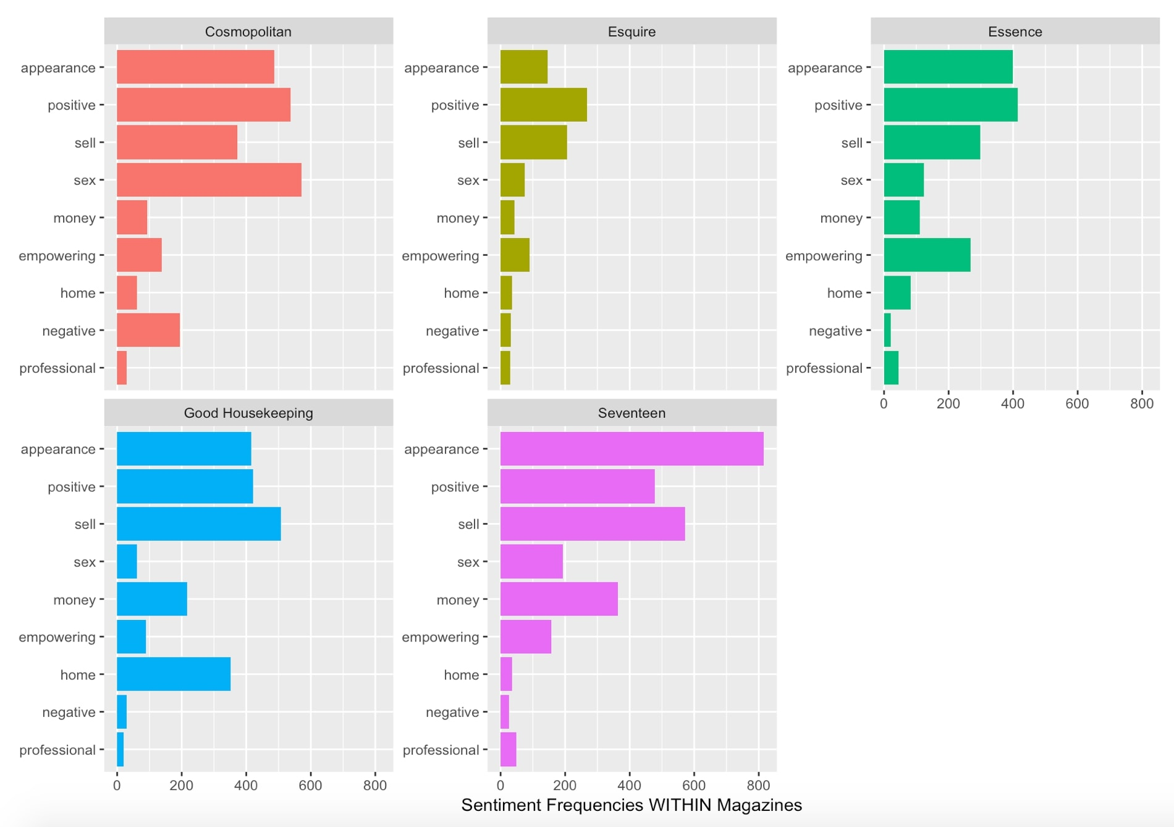

Frequency of different sentiments in each magazine

